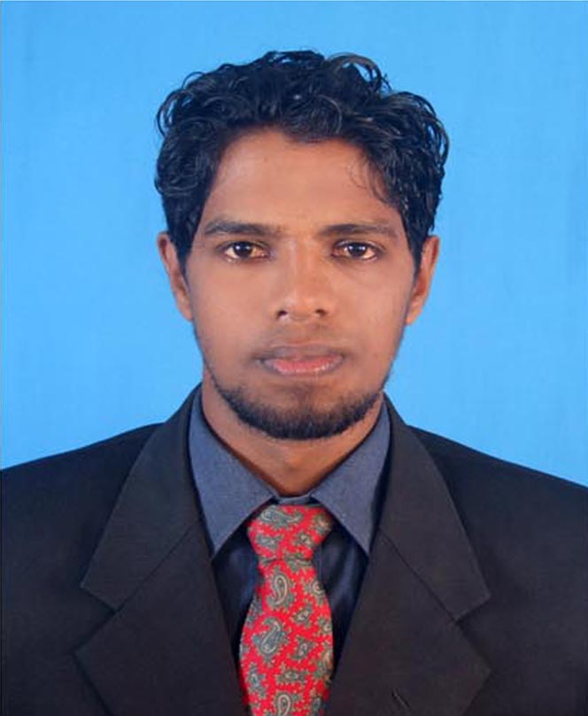
CURRICULUM VITAE
GUNASEKARAGE MAHESH ROSHAN GUNASEKARA
Kumara Mawatha,Hiriyalegama,Nochchiyagama.

Interested in achieving a suitable placement every employment or other, in a growth oriented organization which offers divers job responsibilities in order to utilize and my skills, knowledge and experience.
EDUCATOINAL COLIFICATION

OBJECTIVE

- Passed G.C.E (O/L) in year 2008
Sinhala C
Mathematics C
Buddhism B
Social Studies C
Health A
Sinhala Literature C
Music S
Business & Account S

- Passed G.C.E (A/L) in Year 2011
Economics S
Business S
PRAFESSIONAL QULIFICATION

- Followed a 1st Year Computer Course (MS OFFICE) in Techno world in Anuradhapura.
- Followed a 6th Month Computer Course in Techno World Anuradhapura.
- Followed a 6th Month English Course Completed Level part 01,Nanol Saint in Kandy.

COMPETENCES

- Good Working Knowledge in , Microsoft. (Speed Sinhala type & English)
- Good Knowledge of Graphics Designing
- Good Knowledge of CorelDraw & Photoshop
- Good Knowledge of Computer Hardware
- Good Knowledge of Internet & Email
- Good Knowledge of All Printing Job
PERSONLCOMPETENCES

- Name With Initials - G'M'R Gunasekara
- Date Of Birth - 22nd February 1990
- Sex - Male
- Civil Status - Married
- NIC - 900533071v
- Contact No - 071-8943464
- Address - Kumara Mawatha, Hiriyalegama
Nochchiyagama.
REFERENCE

Principal: - P.B Rathnayaka, Shantha Thero,
Halmilla Kulama, Sri Sarananda Pirivena
Nochchiyagama, Peradeniya,
Anuradhapura. Panideniya
Kandy
T'P 077-9684515
I Hereby Citify that the above Particulars Submitted by me are true and correct to the best Knowledge.

Signature: Mahesh

